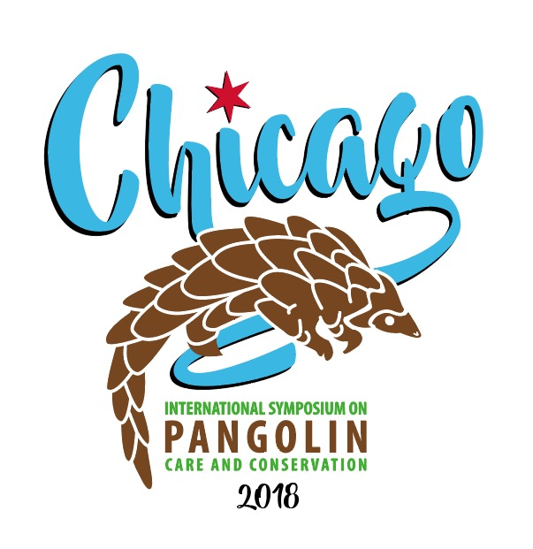

Call for Abstracts
The International Pangolin Symposium will bring together conservation biologists and zoo professionals from around the globe who are dedicated to the care of African and Asian pangolin. The conference will focus on gathering and sharing knowledge of the field biologists and professional animal caregivers to further our understanding of these amazing species. We invite science-based abstracts regarding all aspects of pangolin care and conservation.
Name of Presentor/Author:
Title: Organization:
Mailing Address:
Daytime Phone: Fax:
Email Address:
Presentation Title:
First Author:
Co-Author(s):
Abstracts (no more than 250 words) should be sent to Carrie Jung at the following:
Mail: Carrie Jung
Brookfield Zoo
3300 Golf Road
Brookfield, IL 60513
Email: Caroline.Novosel@czs.org
(Please include Pangolin Symposium in the subject line)
Phone: 708-688-8461

All abstract submissions must include this completed form plus the abstract. The abstract should contain enough information to allow evaluation of the project. Abstracts are to be submitted in Times New Roman 12 font. The official language of the symposium will be English.
Abstracts must be received by April 15, 2018 to be eligible for inclusion in the program. A notice of acceptance will be sent by May 15, 2018. A complete version of the paper for the proceedings will be required by June 15, 2018.

